Nibras
نبراس
AI-Native Enterprise Platform

Proposal for GOFSCO Management
Management Discussion
29 July 2026

Table of Contents
1. Executive Summary
2. Where We Are Today — The Pain Points
3. The Vision — Nibras
4. What Makes Nibras Different
5. System Architecture
6. The AI Coworker — Your Team's New Teammate
7. Implementation Roadmap
8. Investment & Expected Returns
9. Why Now
10. Next Steps

1. Executive Summary
GOFSCO runs on fragmented tools that no longer serve the business. SAGE-300 handles basic accounting. HR relies on an unreliable Hard Task system. Finance tracks everything in Excel. Stores lack any digital inventory management. Documents are scattered across shared drives.
Nibras is an AI-Native Enterprise Platform — a single, unified system designed specifically for oilfield services and manufacturing companies. It replaces the patchwork of disconnected tools with one platform that:
- Unifies finance, procurement, inventory, HR, and operations in one system
- Gives every employee an AI coworker that speaks Arabic and English, answers questions about live data, and proactively alerts you before problems happen
- Automates the manual work — journal entries, purchase orders, stock reordering, payroll calculations, document processing
- Grows with you — start with the modules you need most, add more as you grow

In 24 months, GOFSCO can go from Excel-and-email operations to a modern, AI-augmented enterprise — starting with the quickest wins first.

2. Where We Are Today — The Pain Points
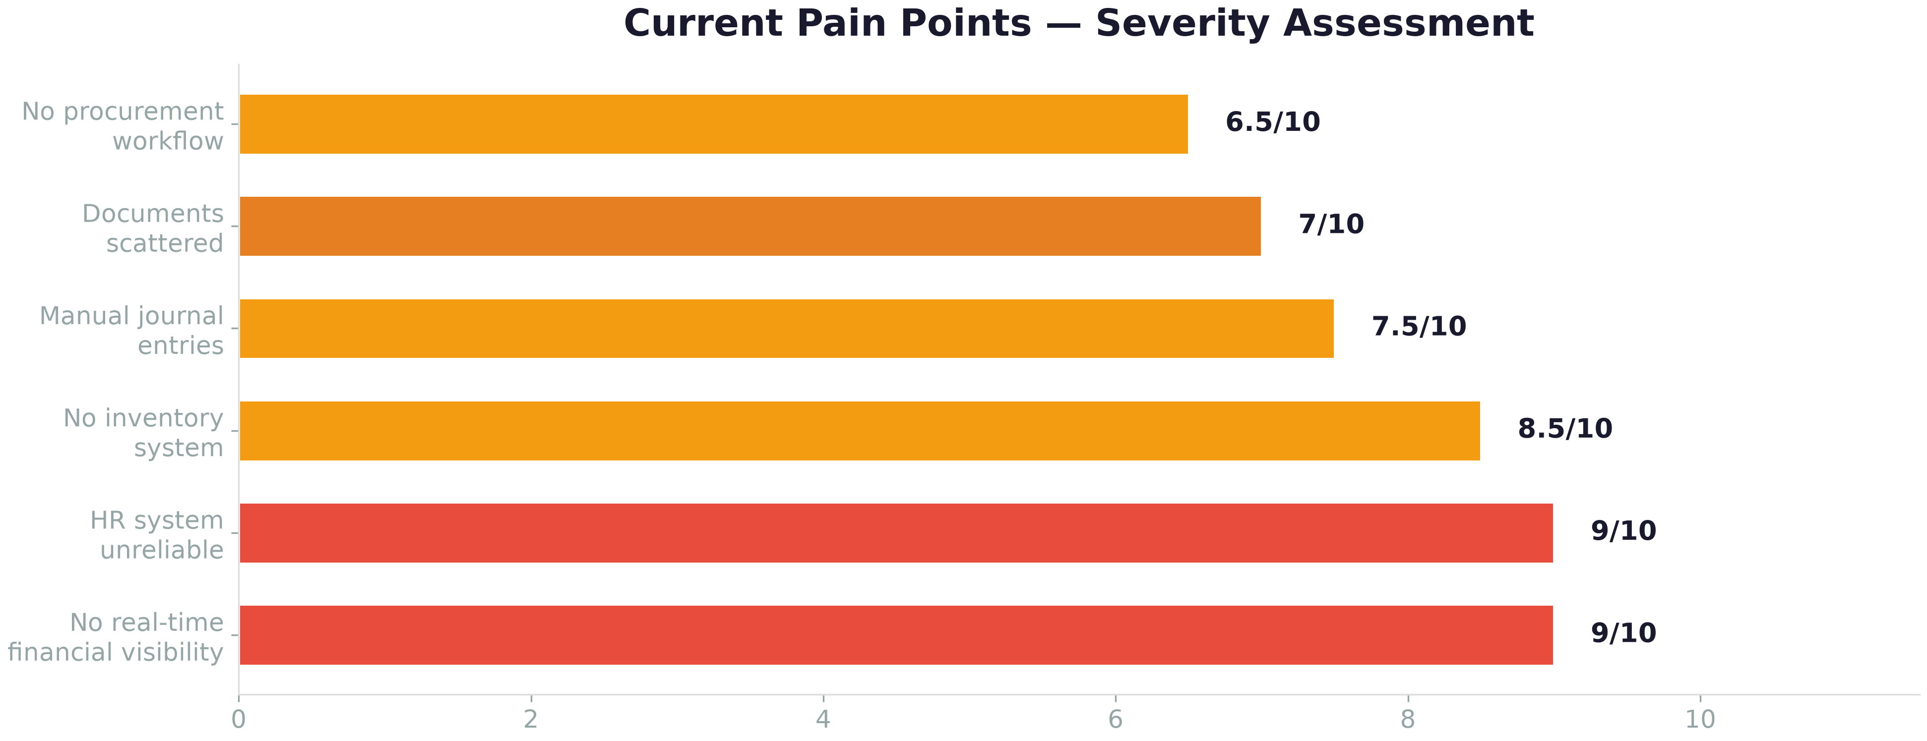

“Every handoff between systems is a manual step. Every manual step is time, risk, and frustration. This is not a people problem. It's a systems problem.”

Finance
Pain Point | Impact
Journal entries prepared manually in Excel | 3-5 days per month-end close, high error risk
No centralized document management | Invoices, receipts, contracts scattered
SAGE-300 is accounting only | Finance team bridges gaps with spreadsheets
No real-time financial visibility | Management decisions based on last month's reports

Human Resources
Pain Point | Impact
Hard Task HRMS described as unreliable | Payroll errors, leave miscalculations, indemnity delays
No integration between HR and Finance | Manual reconciliation every payroll cycle
Employee records fragmented | No single source of truth for personnel data
Loan and ticket tracking separate | Manual tracking, missed deductions

Stores & Inventory
Pain Point | Impact
No digital inventory system | Stock levels unknown without physical count
No ABC classification | Critical spares get same priority as consumables
No reorder automation | Stockouts or overstocking, both costly
No KPIs | Cannot measure turnover, holding costs, or service levels

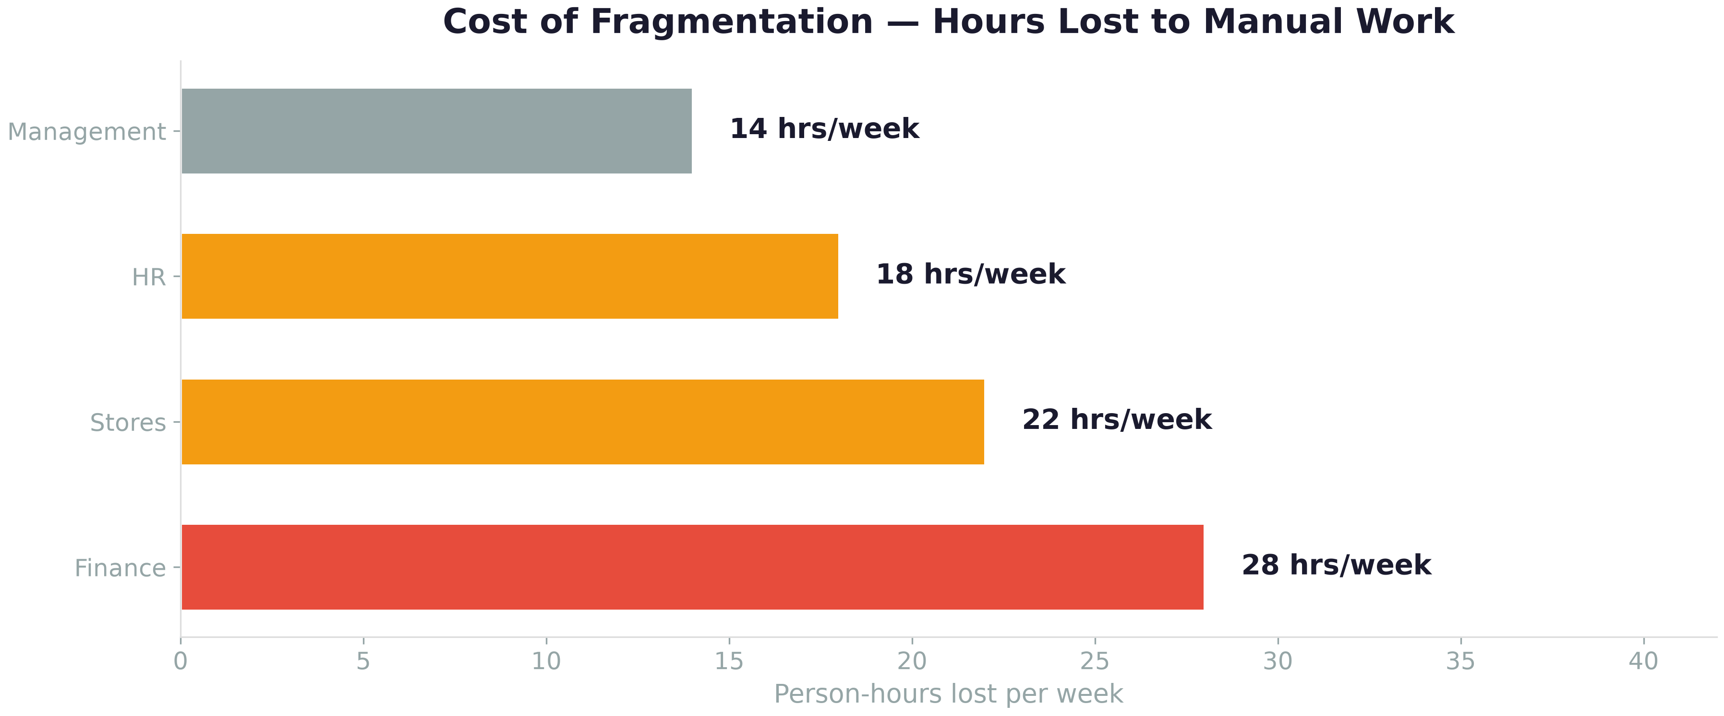

Figure: Person-hours lost per week to manual data entry, reconciliation, and cross-system coordination across departments.

3. The Vision — Nibras
Nibras is not just "new software." It is a fundamentally different approach to running your business — one where data is governed, decisions are informed, and every employee has an intelligent coworker at their side.
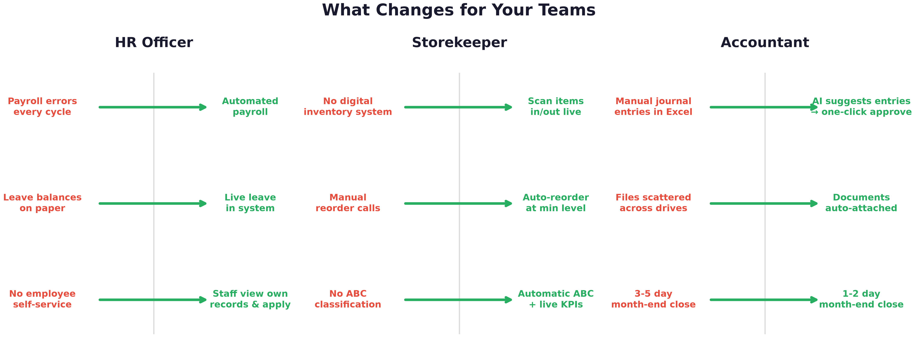

Figure: What changes for key roles across the organization.

One Platform, All Functions
Module | Capabilities | Phase
HR & Payroll | Employee Master, Leave, Payroll, Loans, Indemnity, Self-Service | 1
Inventory | Stock Master, Warehouses, ABC Classification, Auto-Reorder, KPIs | 2
Documents | Central Repository, Full-Text Search, Document Linking | 2
Finance | General Ledger, AP, AR, Budgeting, Bank Reconciliation, Fixed Assets | 3
Procurement | Purchase Requisitions, Purchase Orders, GRN, 3-Way Matching | 3
AI Coworker | Natural Language Q&A, Proactive Alerts, Document Processing | 4
Reports | Dashboards, Financial Statements, Budget vs Actual, Inventory Reports | 1–4

4. What Makes Nibras Different

4.1 AI Coworker, Not Just Another Screen
Every employee gets an AI assistant embedded in the system. It is not a chatbot — it is a coworker that understands your business, uses live data, and acts with your permission.
- Answers questions in Arabic or English — "كم عدد الفواتير غير المدفوعة؟" or "Show me overdue POs"
- Understands your business — knows what a PO is, what a GL account is, what a vendor is
- Uses live data — answers come from the actual system, not guesses
- Alerts you proactively — stock reorder warnings, payment due dates, budget variances
- Processes documents — upload a supplier invoice PDF, it extracts data and drafts the journal entry
- Respects permissions — never shows data to unauthorized users, never acts without confirmation
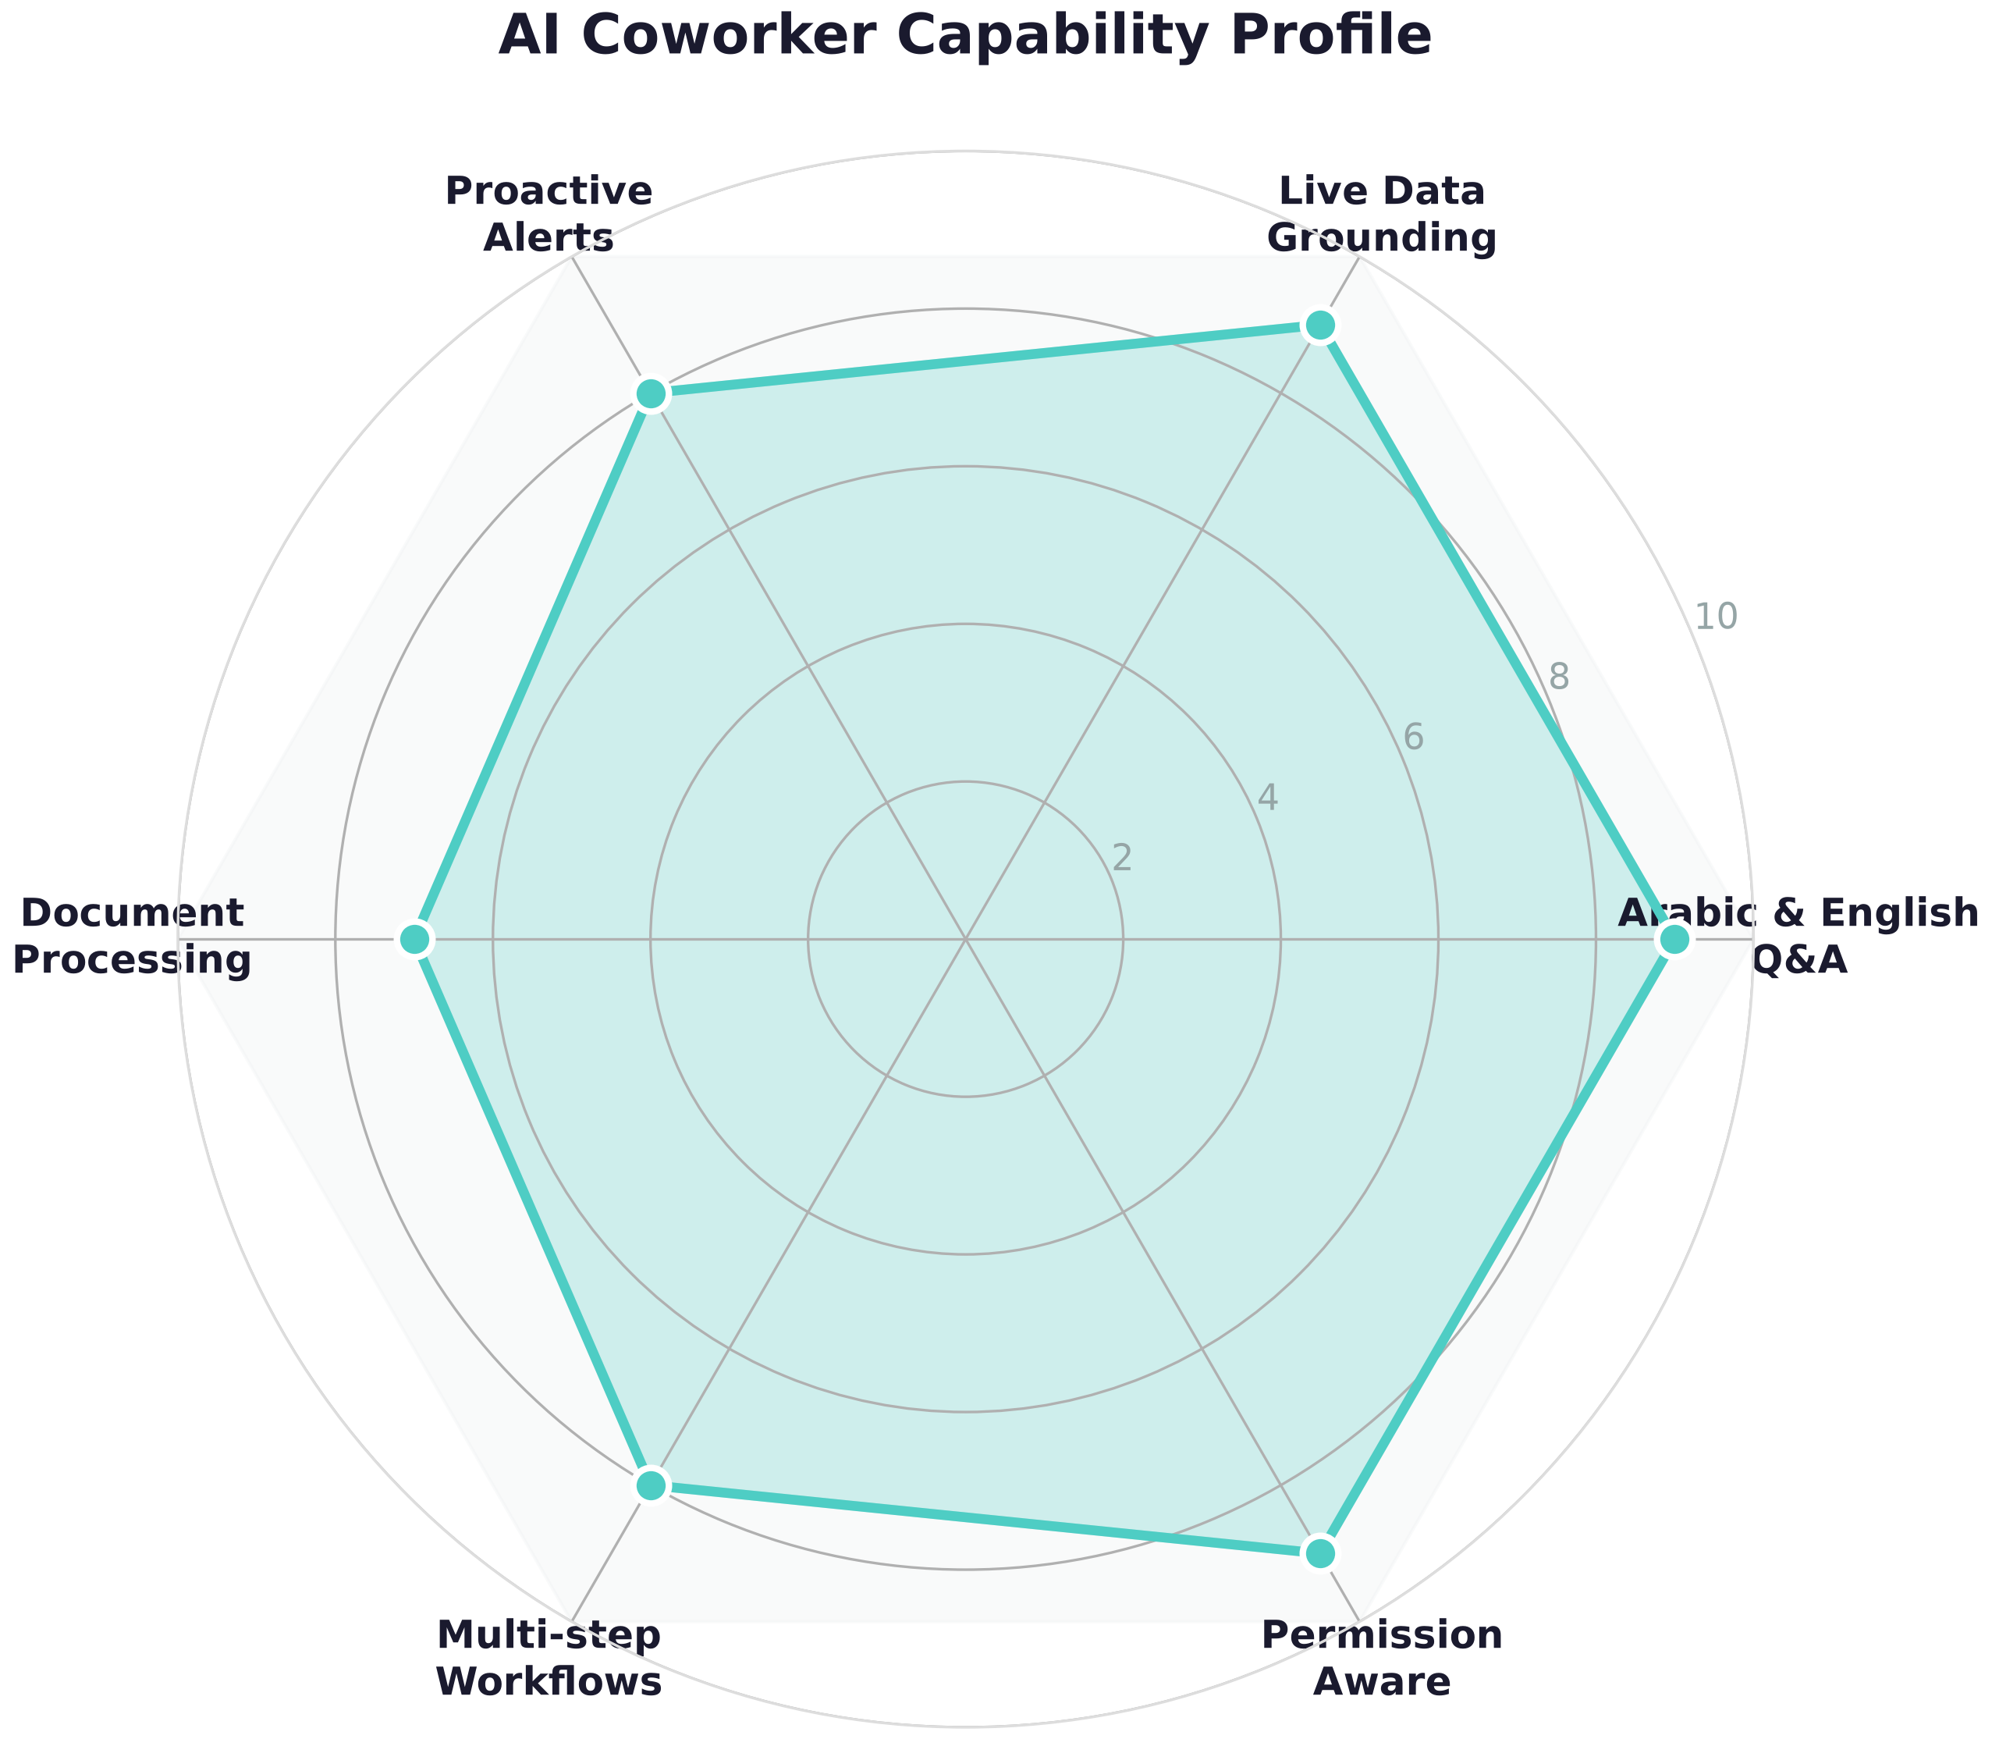

Figure: AI Coworker capability profile across six key dimensions.

4.2 Hybrid Workflows — AI + Traditional
Nibras does not force you to choose between AI and traditional workflows. You get both. The AI does the heavy lifting — finding data, drafting documents, preparing recommendations. The human reviews and makes the decision. Every time.
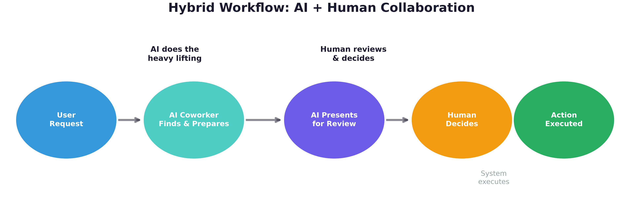

Figure: The AI prepares and presents. The human reviews and decides. The system executes. This is the Nibras collaboration model.

4.3 Built on Data Trust
Most ERP systems become data graveyards — full of duplicates, errors, and inconsistencies. Nibras is built on a Data Trust Platform that ensures:
- One version of the truth — every vendor, every item, every account exists once, correctly
- Data quality rules — the system catches duplicates, missing fields, and anomalies before they cause problems
- Full audit trail — every change is logged. You always know who did what and when
- Governed access — role-based permissions down to the field level

4.4 Mid-Range Enterprise, Not Over-Engineered
Nibras is designed for companies like GOFSCO — 50 to 500 employees, complex enough to need real ERP, lean enough to not need SAP-level complexity and cost.
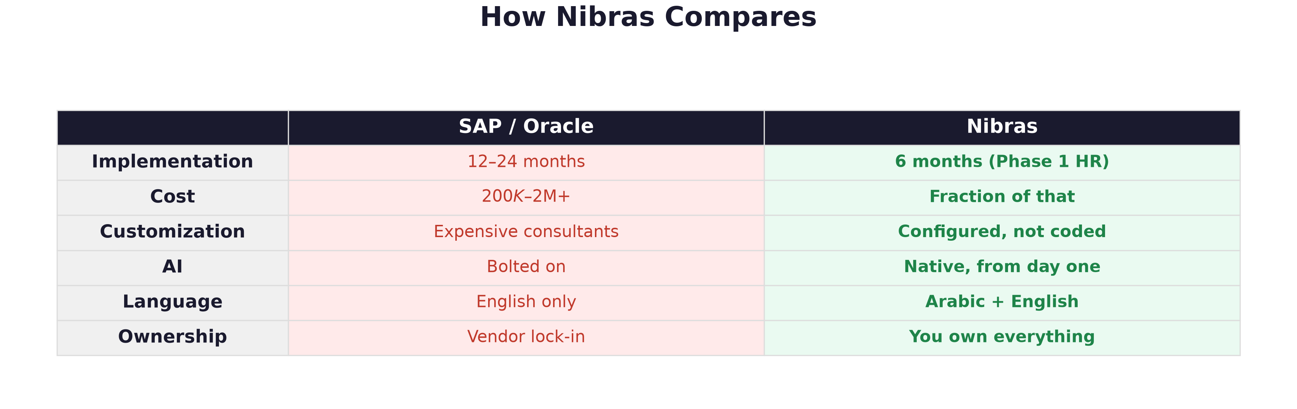

Figure: Nibras vs traditional ERP at a glance.

5. System Architecture
The following diagram shows the four layers of the Nibras platform. Each layer builds on the one below — from the transactional database up through governance, business applications, and the AI coworker interface.
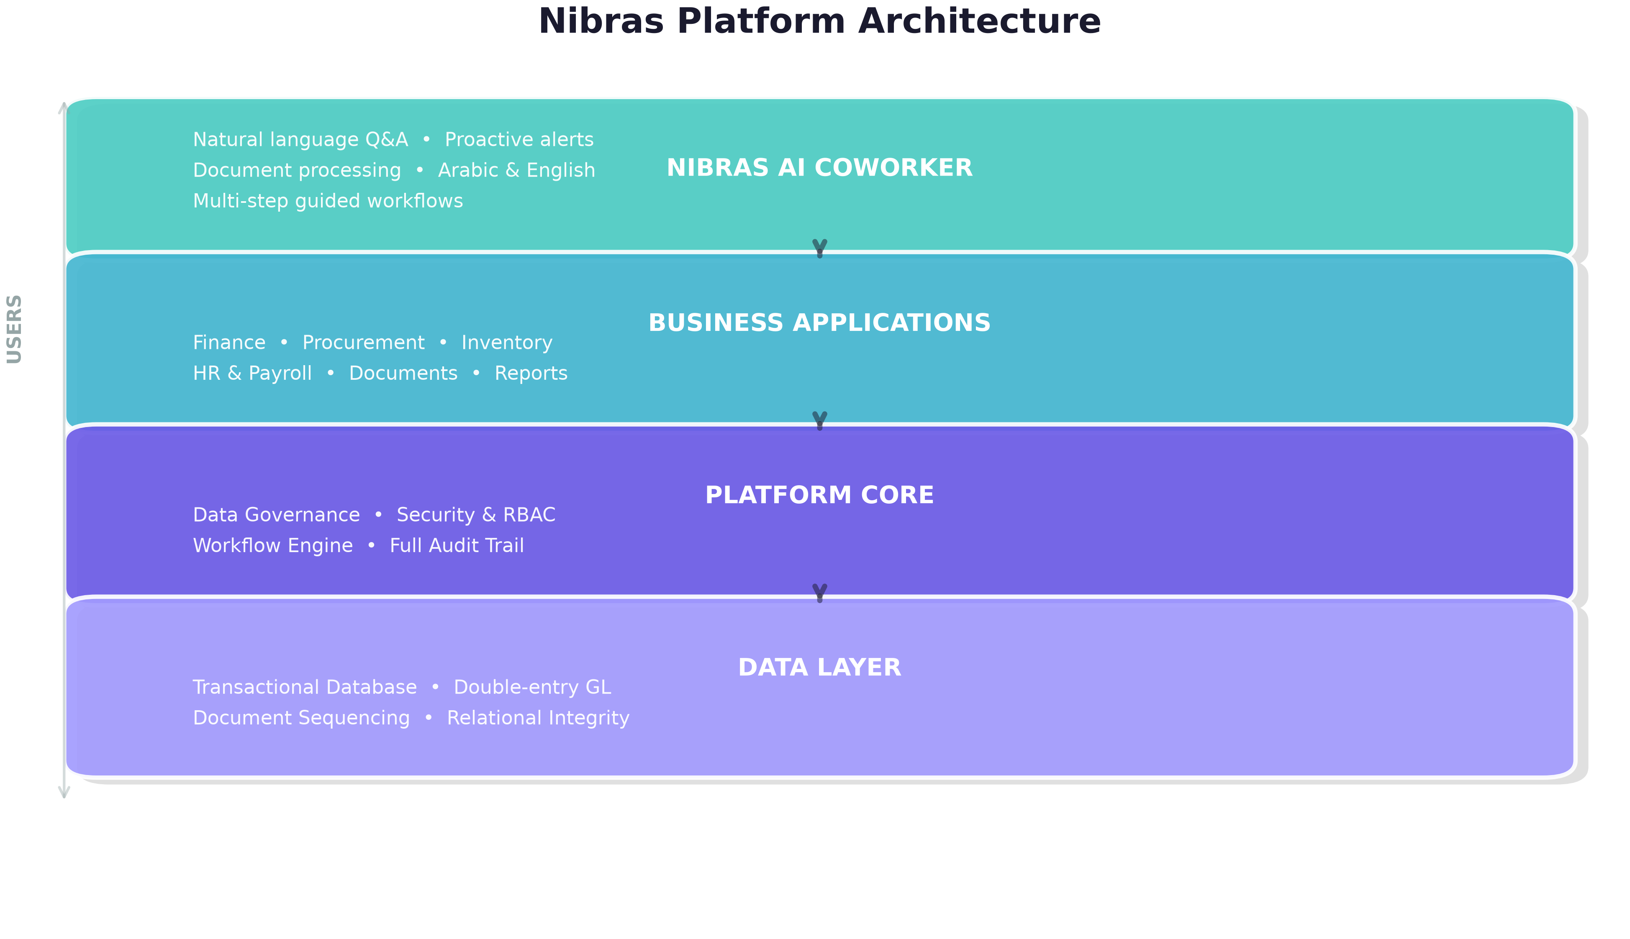

Figure: Nibras four-layer platform architecture.

Key Architectural Decisions
Decision | Rationale
Web-based | Works on any device — desktop, tablet, phone. No installation.
Single database | No integration problems. Finance, HR, Stores share one source of truth.
API-first | Every function is accessible programmatically. Future integrations are trivial.
On-premise or cloud | Deploy where you want — your servers or cloud. You control your data.
Modular | Start with HR. Add Stores, then Finance. Add modules as you grow.

6. The AI Coworker — Your Team's New Teammate
This deserves its own section because it is the single biggest differentiator. Here is what people will actually experience, day to day.
Morning — Finance Manager: Opens Nibras. AI notification: "Good morning. 3 invoices are due this week totaling KD 47,500. Purchase Order #231 is pending your approval. Month-end close is 4 days away — all prerequisite entries are posted."

Midday — Storekeeper: Scans items being issued to a rig. System notices stock of drilling fluid drops below minimum. AI drafts a purchase requisition: "Item X-452 below reorder point (current: 45 units, minimum: 60). Last purchased from Vendor Y at KD 12/unit. Create PR?"

Afternoon — Accountant: Uploads 3 supplier invoice PDFs. AI extracts vendor name, amounts, line items, and tax. Drafts 3 journal entries. Accountant reviews — all correct — approves all 3 in under 2 minutes. Previously: 30+ minutes of manual data entry.

End of Month — CEO: Opens phone. Types in Arabic: "كيف كان أداء الشركة هذا الشهر؟" (How did the company perform this month?) AI responds with revenue, expenses, margin, top 5 customers, budget variance — all from live data.

6.2 Proactive Alerts — The System Watches So You Don't Have To
Alert Type | Example | Triggers When
Stock | Drilling fluid X-452 at 45 units (min: 60) | Below reorder point
Financial | Dept Y budget variance: +18% vs plan | Variance exceeds threshold
Payment | Invoice #4521 due in 3 days — KD 12,500 | Approaching due date
Approval | PO #231 pending your approval — 2 days | Stale approval
Anomaly | 3 POs to Vendor Z this week (avg: 0.5/week) | Statistical outlier
Compliance | Month-end close: bank reconciliation not done | Missing workflow step

6.3 What the AI Will NOT Do
✗ Make decisions without human approval on any financial transaction
✗ Show data to unauthorized users
✗ Execute payments or transfers
✗ Modify system configuration
✗ Share GOFSCO data with any external system
“The AI is a coworker, not a replacement. It amplifies your team's capabilities. It does not replace their judgment.”

7. Implementation Roadmap
Nibras is delivered in four phases over 24 months, starting with the easiest, highest-pain modules first. HR replaces the failing Hard Task system immediately. Finance — the hardest module — comes after the platform has proven itself. Each phase has its own go-live milestone. You receive value at every step — not just at the end.
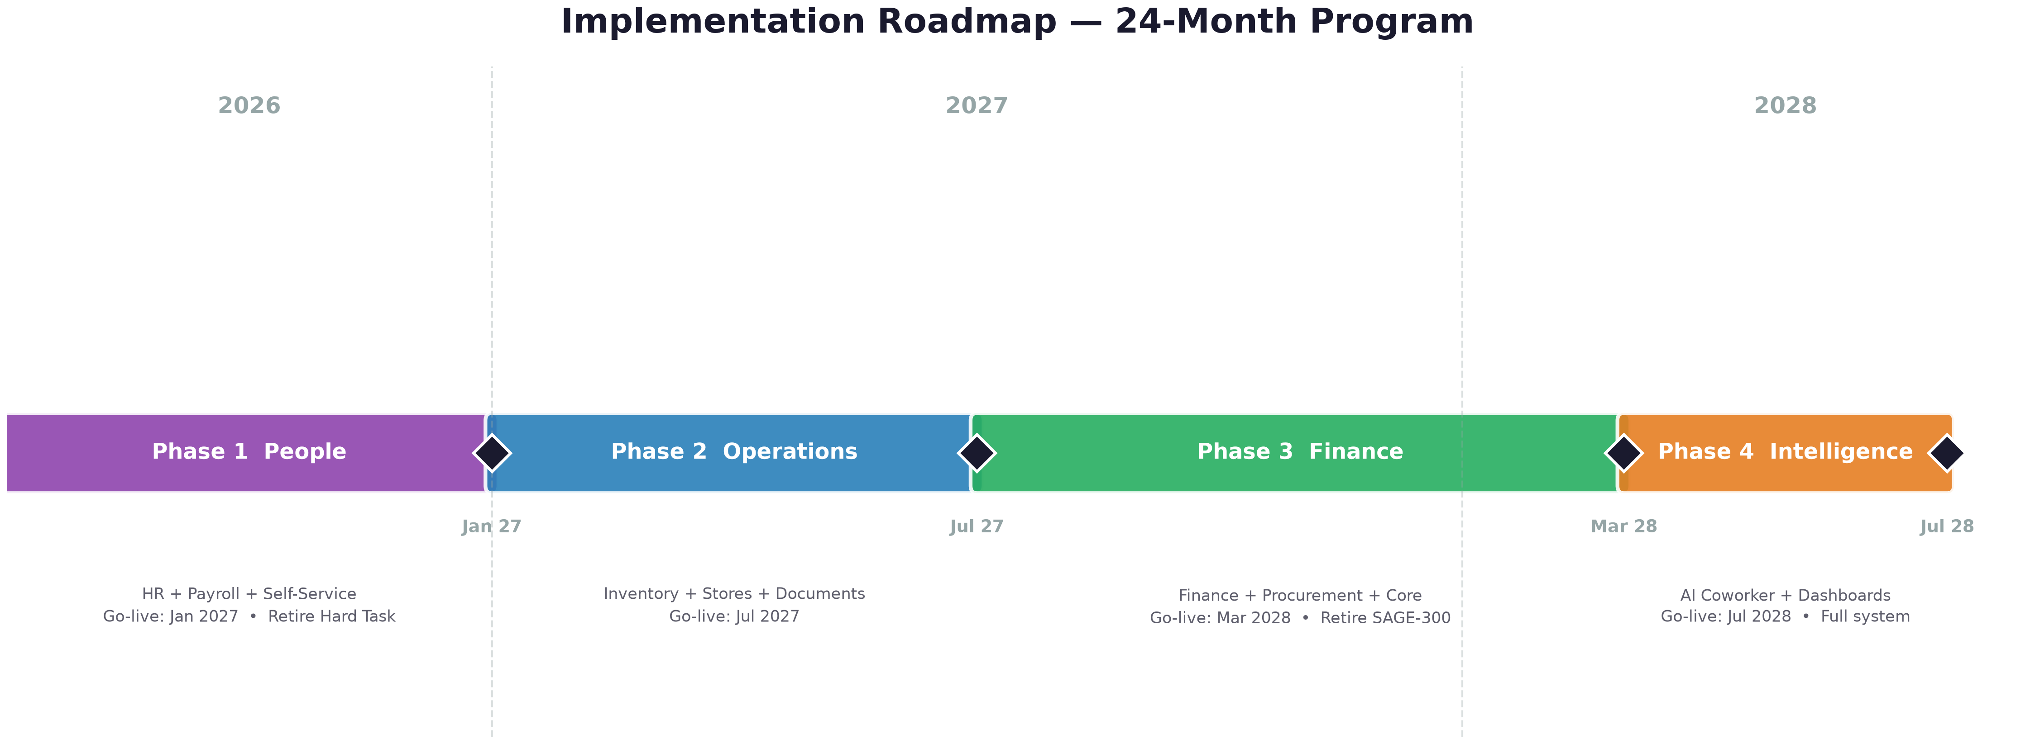

Figure: 24-month implementation program across four delivery phases. Easiest first, hardest last.

Phase 1 — People (Months 1–6)
Goal: Replace Hard Task HRMS immediately. HR is the easiest module and the biggest pain point — payroll errors affect every employee.
- Platform core: Data governance, security, workflows, audit trail — built once, used by all modules
- Employee master: Complete personnel records — single source of truth for all HR data
- Leave management: Balances, requests, approvals, accruals — automated and accurate
- Payroll: Salary calculation, deductions, overtime, allowances — no more errors
- Loans & tickets: Automated installment deductions, ticket accruals and tracking
- Indemnity: Automated calculation per Kuwait labor law
- Employee self-service: Staff view own records, apply for leave, download payslips
- Data migration: Employee master, leave balances, loan balances from Hard Task
✓ Go-live: HR team and all employees on Nibras. Hard Task retired. Payroll errors eliminated.

Phase 2 — Operations (Months 7–12)
Goal: Digital stores, inventory control, and centralized documents. No legacy system to fight — greenfield deployment.
- Inventory management: Stock items, warehouses, stock in/out, transfers — live tracking
- ABC classification: Automatic ABC categorization based on value × consumption
- Reorder automation: Min/max levels, automatic PR generation when stock is low
- Store KPIs: Turnover ratio, holding cost, stockout rate, service level — live dashboards
- Document management: Central repository for all documents with full-text search
✓ Go-live: Stores team on Nibras. Physical inventory count digitized. Stockouts visible in real time.

Phase 3 — Finance (Months 13–20)
Goal: The hardest module, tackled after the platform is proven. Replace SAGE-300 and Excel-based finance with a double-entry system the AI can help operate.
- General Ledger: Double-entry accounting, chart of accounts, AI-assisted journal entries
- Accounts Payable: Vendor invoices, payment tracking, approval workflows
- Accounts Receivable: Customer invoices, collections tracking
- Budgeting: Department budgets, variance tracking, budget vs actual
- Procurement: Purchase requisitions, purchase orders, GRN, 3-way matching
- Bank reconciliation: Automated matching, exception handling
- Fixed assets: Asset register, depreciation schedules
- Data migration: Chart of accounts, open balances, vendor/customer master, historical transactions from SAGE-300
✓ Go-live: Finance + Procurement teams on Nibras. SAGE-300 retired. Month-end close: 3–5 days → 1–2 days.

Phase 4 — Intelligence (Months 21–24)
Goal: Activate the AI coworker across the full platform. From "system of record" to "system of intelligence."
- AI Q&A: Natural language queries across ALL modules in Arabic and English
- Proactive alerts: Automated notifications for stock, payments, approvals, anomalies — system-wide
- Document AI: Upload PDF invoice → auto-drafted journal entry. Upload contract → extracted metadata
- Advanced dashboards: Role-based analytics for every level — operator to CEO, with AI commentary
- Workflow automation: Multi-step processes with AI assistance — purchase-to-pay, hire-to-retire
✓ Go-live: Complete Nibras system. All legacy systems retired. AI coworker active across all departments.

8. Investment & Expected Returns

8.1 What You Are Investing In
Nibras is not a license fee for someone else's software. It is your system, built for your business, that you own.
Component | Description
Platform development | The Nibras core — data trust, security, workflows, AI, integrations
Business modules | Finance, procurement, inventory, HR — configured for GOFSCO
Data migration | Moving your data from SAGE-300, Hard Task, and Excel into Nibras
Training & adoption | On-site training, user documentation (Arabic + English), go-live support
Infrastructure | Server setup, deployment, backup configuration

8.2 Expected Returns
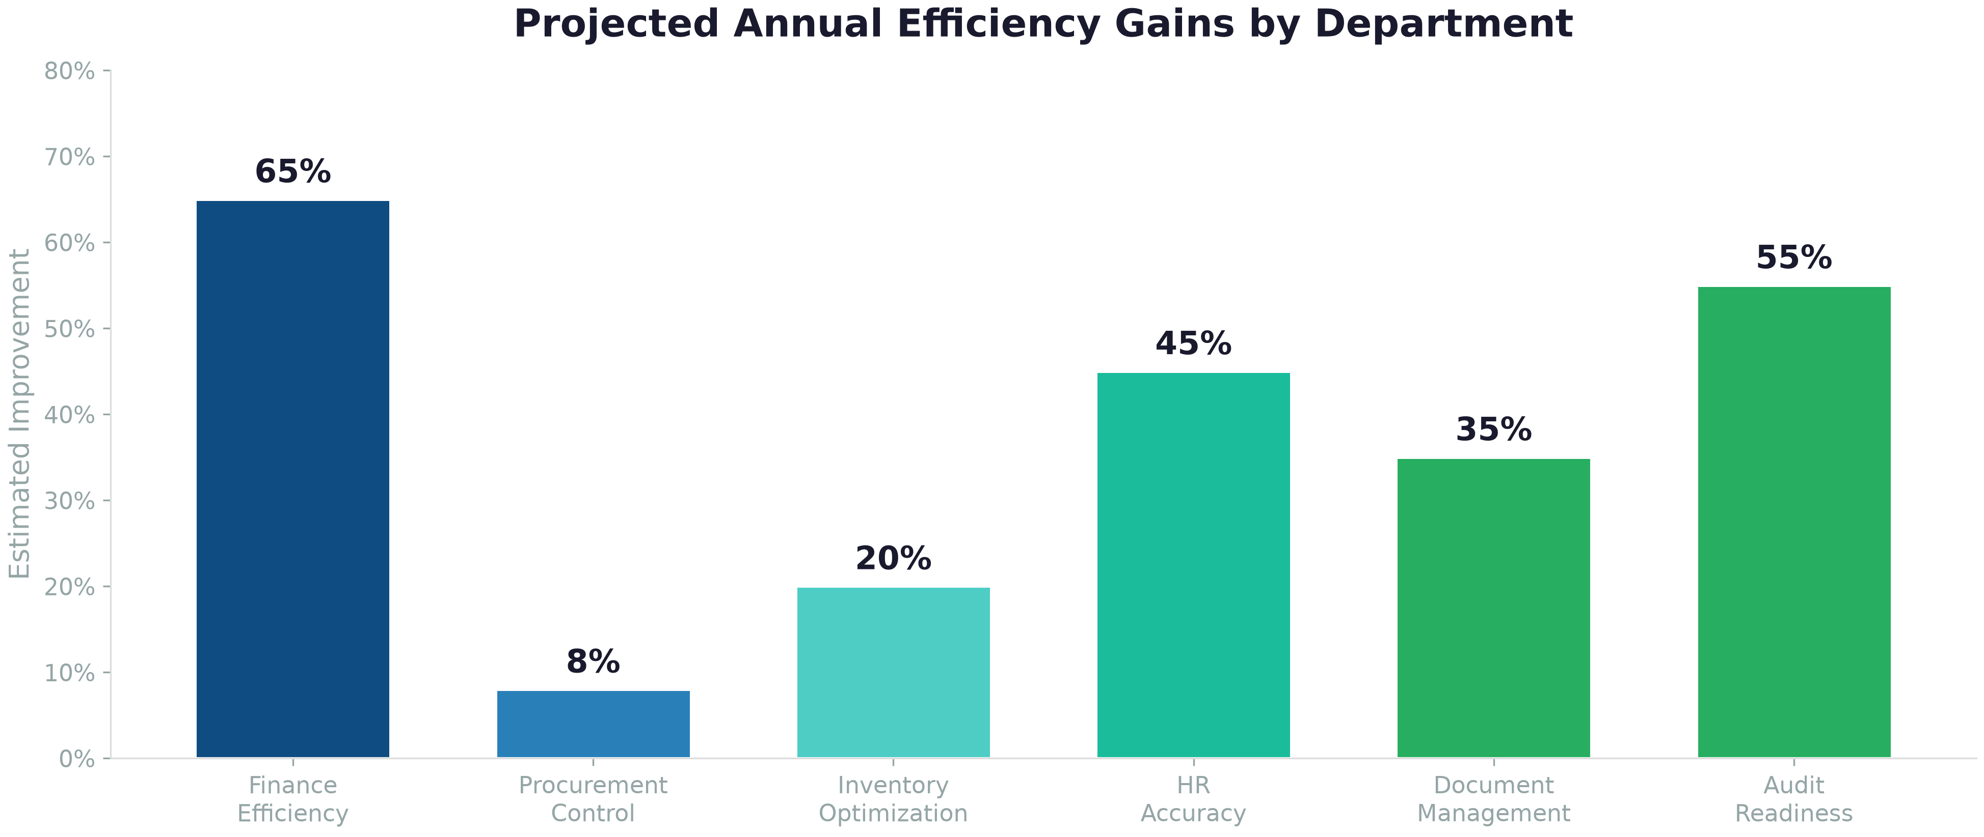

Figure: Projected annual efficiency gains by department.
Category | Annual Benefit
Finance efficiency | 60–70% reduction in month-end close time (3–5 days → 1–2 days)
Procurement control | 5–10% procurement cost reduction via 3-way matching and controls
Inventory optimization | 15–25% holding cost reduction via ABC + auto-reorder
HR accuracy | Elimination of payroll errors. 40–50% reduction in HR admin time
Document management | 2–3 hours/week saved per knowledge worker
Decision speed | Live dashboards + AI Q&A. Decisions based on today's data
Audit readiness | 50%+ reduction in audit preparation time with complete audit trail

8.3 Cost Structure
Nibras follows a build-transfer-operate model:
Build (Years 1–2): Development investment across 4 phases. You fund building your system.
Transfer (End of Year 2): You own the system — the code, the data, everything.
Operate (Year 3+): Annual support and enhancement. A fraction of the build cost.
No per-user license fees. No hidden modules. No vendor lock-in. Compare with ERP alternatives charging $100–200/user/month in perpetuity.

9. Why Now

9.1 The Cost of Waiting
- ~60–80 person-hours lost to manual data entry and reconciliation every month
- Payroll errors creating employee dissatisfaction
- Stockouts or overstocking with no visibility
- Management decisions lagging by 30 days
- Institutional knowledge trapped in people's heads and personal spreadsheets

9.2 The Technology Window
Three things have converged to make this possible at mid-market cost:
1. AI has matured. What required a team of data scientists 3 years ago is now accessible as an embedded capability.
2. Web platforms are production-ready. Modern frameworks deliver enterprise reliability without enterprise cost.
3. Your data is ready. SAGE-300 and your Excel files contain clean enough data to migrate. We have audited it.

9.3 The Competitive Context
Oilfield services is competitive. The companies that will lead in 2030 are the ones that digitized their operations in 2026–2027. Companies still running on Excel and fragmented legacy systems will struggle to respond quickly to RFQs, manage complex supply chains for multiple rig sites, retain talent with modern tools, and demonstrate compliance to international operators.

10. Next Steps

This Week
Step | Who | Duration
Management briefing — Present proposal, answer questions | GOFSCO Management + Nibras team | 2 hours
Scope confirmation — Agree which modules in which order | Joint workshop | 1 session
Site survey — Review IT infrastructure, SAGE-300 access | Nibras technical team | 1 day

This Month
Step | Who | Duration
Detailed requirements — Department walkthrough | GOFSCO dept heads + Nibras team | 1 week
Data audit — SAGE-300, Hard Task, Excel quality | Nibras data team | 1 week
Technical proposal — Architecture, security, compliance | Nibras engineering | 2 weeks
Commercial proposal — Fixed-price Phase 1, estimates Phases 2–4 | Nibras | 1 week

Decision Gate
After the detailed requirements and commercial proposal, a go/no-go decision on Phase 1. The investment is staged — commit to Phase 1 (HR + Payroll, 6 months). If it delivers, continue to Phase 2. If it does not, you have a working HR system replacing Hard Task and no further obligation. Finance comes later, when the platform is proven.

"The best time to plant a tree was 20 years ago. The second best time is now."
The same is true for enterprise systems. Every month of delay is a month of unnecessary manual work, invisible risks, and missed opportunities.
Let's light your beacon.

نبراس · Nibras · AI-Native Enterprise Platform
Prepared by the Nibras Team · Confidential — Management Discussion · 29 July 2026

